 | 

━━━━━━━━

NutriScan
Graduation Project Documentation
9-MONTH PROGRAM · INTAKE MAD-46 | ANDROID · iOS · BACKEND
Project | NutriScan
Version | 1.1
Release period | 13 July – 15 August 2026
Prepared by | Android, iOS, and Backend teams
Supervised by | Narden Ayad

TEAM
Android — Ahmed Tayseer · Ashraf Sherif · Noureldeen Osama · Youssef El-Lban
iOS — Albaraa Alsayed · Ahmed Nageh · Osama Hosam · Mina Wagdy · Youssef Abd El-Fatah
Backend — Ibrahim Gad · Ibrahim Soliman · Reem Mohy

Acknowledgment
We would like to express our sincere gratitude to the Information Technology Institute (ITI) and the Ministry of Communications and Information Technology for providing the environment, the equipment, and the nine months of intensive training that made this project possible.
Our deepest thanks go to our supervisor, whose guidance shaped both the technical direction and the engineering discipline of this work, and to the instructors of the Native Mobile Application Development (Android and iOS) and Backend Web Development tracks, who taught us not only how to build for each platform but how to reason about architecture, testing, and maintainability across the full application stack.
We also thank our QA colleagues, Mina Mofreh and Ahmed Abouelella, who tested the application on real devices and produced the bug report that drove the final hardening round.
Finally, we thank our families for their patience during the long weeks of sprints, reviews, and late-night debugging.

Table of Contents
PART 1: Overview
Abstract
Introduction
Objectives
PART 2: Characteristics
Features
PART 2.1: SDLC
Analysis
Design
Implementation
Tools
PART 3: Illustrations
PART 3.1: Diagrams
ERD — Entity Relationship Diagram
Use Case Diagram
Class Diagram
PART 3.2: Screenshots
iOS Application
Android Application
Backend / Admin System
References

Abstract
Food labels are written for regulators, not for people. A shopper with a peanut allergy, a diabetic checking added sugar, or a parent buying a snack for a child with celiac disease is expected to decode an ingredient list printed in six-point type, in a language that may not be their own, while standing in a supermarket aisle. The information required to make a safe decision exists — it is simply not usable at the moment of the decision.
NutriScan is a cross-platform mobile application — available natively on both Android and iOS — that closes that gap. The user points the camera at a product: either its barcode or its ingredient panel. Within seconds the application returns a personalised verdict — Safe, Caution, or Unsafe — computed against that specific user’s recorded allergies and chronic conditions, together with the exact ingredients that triggered the verdict and a full nutrition breakdown.
Around this core, NutriScan provides the daily-health context that makes a single scan meaningful: calorie and meal logging, water intake, step counting, a guided exercise library, a personalised nutrition news feed, a streak system, a configurable notification engine, and NutriGPT, a retrieval-augmented conversational assistant that answers nutrition questions in text or by voice and cites its sources.
The Android application is written entirely in Kotlin with Jetpack Compose, built on Clean Architecture across four Gradle modules with a strict MVI presentation contract, and is offline-first with a Room database as the single source of truth.
The iOS application is written entirely in Swift with SwiftUI, built on Clean Architecture with a feature-first module layout and an @Observable-driven MVVM presentation contract, and integrates with HealthKit for native step tracking.
Both clients consume the same NutriScan REST backend and authenticate against a self-hosted Keycloak identity provider using OpenID Connect. The backend is powered by a Java/Spring Boot service with an AI-driven scan analysis pipeline.
The final release is version 1.1, produced by a team of Android, iOS, and backend engineers over five sprints between 13 July and 15 August 2026.

Introduction

The problem
Chronic diet-related disease and food allergy are both rising, and both place the same demand on the individual: continuous, correct, per-product decisions.
A person with a severe allergy must verify every packaged product they eat. A single missed derivative name — casein for milk, semolina for gluten, E120 for an animal-derived colourant — is a clinical event, not an inconvenience.
A person managing diabetes, hypertension, or kidney disease must track sugar, sodium, and protein against a target they cannot compute mentally from a per-100g table.
Ingredient panels are dense, often bilingual, sometimes unreadable, and never personalised. They tell the reader what is in the product; they never tell the reader whether the product is safe for them.
Existing nutrition applications solve the adjacent problem — calorie counting — and treat safety as a manual search task. The user is still the one who must read, recognise, and decide.

The idea
NutriScan inverts that relationship. The user tells the application, once, who they are: their allergies, their chronic conditions, their body metrics, and the same information for their family members. From that point on, every product the user scans is evaluated against that profile, and the answer is delivered as a verdict a person can act on in one glance, before the product goes into the basket.
Two capture paths feed the same evaluation pipeline:
Barcode scan — on-device barcode detection reads the barcode from the live camera preview; the product is resolved from the NutriScan backend, falling back to the OpenFoodFacts open database.
Photo scan — the user photographs the ingredient panel; the image is uploaded and analysed server-side, returning the same structured result.
Both return a ScanResult: a verdict, a summary, a list of flagged ingredients with the reason each was flagged, and a normalised nutrition-facts block.

Beyond the scan
A verdict is a moment. Health is a habit. NutriScan therefore wraps the scanner in a daily-health loop: what the user ate (food log, fed directly from scan results), what they drank (water tracking), how much they moved (step counting plus a guided exercise library with per-exercise calorie estimates), and how consistently they did it (streaks and a notification engine that nudges without nagging).
The result is an application where a single scan is not an isolated lookup but an entry in a continuous personal health record.

Document structure
Part 1 states the project’s abstract, motivation, and objectives. Part 2 details the delivered feature set and walks through the software development lifecycle for the Android client: requirements analysis, architectural and UI design, implementation of the key technical subsystems, and the tooling used. Part 2.2 covers the iOS client architecture and implementation. Part 3 summarises the backend. Part 4 presents the system diagrams and application screenshots, followed by references.

Objectives

Primary objective
Deliver production-quality native mobile applications — for both Android and iOS — that turn a packaged food product into a personalised safety verdict in under ten seconds, using only the device camera and a health profile the user configures once.

Product objectives
Personalised safety, not generic data. Every verdict is computed against the signed-in user’s allergy and chronic-condition profile. The same product can be Safe for one account and Unsafe for another on the same device.
Two capture paths, one result. Barcode and ingredient-panel photo must produce the same structured ScanResult so that downstream features (history, saving, food logging) never need to know how a scan originated.
Explainability. The application never returns a bare verdict. It returns the specific flagged ingredients and why each was flagged, so the user can override an over-cautious result with informed judgement.
A complete daily-health loop. Calories, meals, water, steps, exercise, and streaks — so that a scan feeds a record rather than evaporating.
Family coverage. Allergy profiles are not only personal. A parent must be able to store family members with their own allergies and conditions.
Assistance on demand. NutriGPT answers free-form nutrition questions with cited sources, by keyboard or by voice, for users who cannot or prefer not to type.
Full bilingual parity. English and Arabic must be first-class: every string localised, full RTL layout mirroring, and an Arabic-appropriate typeface — not a translated afterthought.
Cross-platform parity. Android and iOS users receive the same feature set, the same verdict logic (server-side), and the same backend services.

Android engineering objectives
Clean Architecture with enforced boundaries. Four Gradle modules with a strict dependency rule (presentation → domain ← data) and a :domain module that is pure Kotlin with zero Android dependencies.
A single, uniform presentation contract. Every feature implements the same MVI triad (State / Event / Effect) with StateFlow for state and a Channel for one-shot effects.
Offline-first by default. The Room database is the single source of truth.
Testability as a delivery requirement. Every ViewModel ships with a test file covering state transitions, effects, and error paths.
Secure authentication. Standards-based OpenID Connect against a self-hosted Keycloak realm, with tokens held in encrypted storage.
Modern Android baseline. 100% Kotlin, 100% Jetpack Compose, no XML layouts, no Fragments, type-safe navigation, minSdk 31 / targetSdk 36.

iOS engineering objectives
Clean Architecture with feature-first modules. Each feature owns its Domain, Data, and Presentation layers; shared services live in Core.
@Observable-driven MVVM. Every screen is a stateless SwiftUI view driven by an @Observable ViewModel; all state flows through value-type state structs.
Coordinator-based navigation. AppFlowCoordinator owns top-level flow transitions (splash → onboarding → auth → profile setup → main tabs → account restoration); each tab maintains its own independent NavigationStack via AppRouter.
Native platform integration. HealthKit for real-time step counting; AVFoundation and the Speech framework for voice input and text-to-speech in NutriGPT voice mode; AVCaptureSession for barcode scanning.
Secure credential storage. Tokens stored in the iOS Keychain via KeychainManager; transparent token refresh handled by TokenRefresher at the network layer.
Modern iOS baseline. 100% Swift, 100% SwiftUI, @Observable macro, Swift Concurrency (async/await), minimum deployment target iOS 17.

Features
This section documents the implemented feature set of NutriScan v1.1, verified against the Android and iOS repositories.

1. Onboarding and authentication
Feature | Description
Splash | Branded launch screen; routes to onboarding, login, profile setup, or home based on session and profile state.
Onboarding carousel | Three-page introduction shown once; the “seen” flag persists in storage.
Register | Email/password registration against the NutriScan backend, with client-side validation and email-verification handoff.
Email verification | Verification-pending screen with resend support and rate-limit feedback.
Login | Email/password login.
Forgot password | Email-based password reset flow.
Profile setup pager | A multi-step flow collecting gender, date of birth, height, weight, chronic conditions, and allergies. BMI and TDEE are derived on completion.
Account deletion / restoration | Soft deletion with a pending-deletion state and a restore path within the grace window.

2. Scanning — the core feature
Feature | Description
Camera screen | A single camera-backed screen handling both modes. Barcode detection runs continuously in the live preview; the shutter captures the ingredient panel for photo analysis.
Barcode resolution | Barcode sent to NutriScan backend POST /v1/scans/barcode, falling back to the OpenFoodFacts public API.
Photo analysis | Image sent to POST /v1/scans (multipart) and returns a structured ScanResult.
Verdict | Every scan resolves to SAFE, CAUTION, or UNSAFE, computed server-side against the signed-in user’s allergies and chronic conditions.
Product details | Verdict banner, product image and name, flagged-ingredient list with reasons, and a full nutrition-facts panel (calories, protein, carbohydrates, fat, fibre, sugar, sodium).
Add to food log | One tap adds the scanned product to today’s meals with its calorie value.
Scan history | Full history with search, verdict filters (Safe / Caution / Unsafe), date filtering, and delete with confirmation.
Saved scans | Favourite/unfavourite any scan; saved scans sync to the backend.

3. Calories and daily tracking
Feature | Description
Calories dashboard | Daily calories consumed against the TDEE-derived target, with a macro breakdown.
Food log | Today’s meals, added from scans or manually; removable with confirmation.
Water tracking | Cup-based intake against an adjustable daily target.
Step counting | Automatic step counting — Android uses a foreground hardware step-counter service; iOS uses HealthKit. Calories-burned derivation on both.
Calories history | Per-day historical breakdown (consumed, water, exercise, steps) with date navigation.
Step history | Historical step data with daily detail.
Streaks | Consecutive-day goal-completion streak, synced with the backend.

4. Exercises
Feature | Description
Exercise library | Backend-served exercise catalogue browsable by category, body part, equipment, and target muscle, with search and paging.
Workout screen | Animated GIF demonstration, step-by-step instructions, targeted and secondary muscles, and per-repetition / per-minute calorie estimates.
Workout logging | Completed workouts add their calorie burn to the day’s tracking record.

5. News
Feature | Description
News home | Curated nutrition and health headlines on the home screen.
News list | Full article list with topic filtering, sourced from NewsAPI.
News detail | In-app article reading, with a web view for the full source.

6. NutriGPT assistant
Feature | Description
Chat | Free-form nutrition Q&A against a retrieval-augmented backend (POST /api/query). Answers list the sources they were drawn from.
Voice mode | Hands-free conversation: on-device speech recognition for input and text-to-speech playback of the answer, with an animated listening/speaking state.

7. Profile, family, and settings
Feature | Description
User profile | Personal details, body metrics, BMI, TDEE, allergies, and chronic conditions.
Edit profile | Full profile editing with avatar capture/upload.
Family members | Create, edit, and delete family members, each with their own allergy and chronic-condition sets and profile image.
App settings | Theme (light / dark / system) and language (English / Arabic), both persisted and applied instantly.
Notification settings | Per-type toggles plus quiet-hours windows.
Notification history | A persisted, readable log of every notification the application has raised, with read/unread state.
Help and Terms | In-app help content and terms & conditions.

8. Cross-cutting features
Bilingual EN / AR — full localisation in English and Arabic, with complete RTL layout support.
Light and dark themes — a semantic design-token system; no hard-coded colours in any view.
Accessibility-conscious UI — content descriptions/accessibility labels, shimmer/skeleton placeholders during loading, and standardised empty and error states across every screen.

PART 2.1: SDLC
This section presents the Software Development Life Cycle for the complete NutriScan system across Android, iOS, and Backend components.

Analysis

Development methodology
The project followed an Agile / Scrum process over five iterations — a Sprint 0 setup iteration followed by Sprints 1 to 3 and a final stabilisation and hardening phase — running from 13 July 2026 to 15 August 2026. Work was tracked on a Trello board (NutriScan, board 3j0IimeG) with six lists modelling the delivery pipeline:
List | Purpose
Product Backlog | All identified work, unscheduled.
Sprint Backlog | Committed scope for the active sprint.
In Progress | Actively being developed.
Bugs | Defects raised by QA or the team.
Code Review | Awaiting peer review on a pull request.
Done | Merged and verified.

Cards were prioritised with MoSCoW labels (must have, should have) and tagged by iteration (sprint 0, sprint 1, sprint 2, sprint 3) plus cross-cutting epics such as Auth integration. At delivery, 106 cards were in Done.

Sprint breakdown
Sprint | Focus | Representative delivered cards
Sprint 0 (20 cards) | Foundations and skeleton | GitHub repository setup, modularisation, Hilt DI setup, Retrofit network layer, Room database setup, Navigation Component setup, splash, onboarding, login/register/forgot-password UI, profile-setup pager, home screen, bottom navigation, localisation (EN/AR), search infrastructure.
Sprint 1 (9 cards) | Authentication and profile integration | Login, registration, and forgot-password backend integration via Keycloak; profile integration; scan integration; health-profile setup; edit-profile screen; settings; saved-scans screen.
Sprint 2 (9 cards) | Scanning and user data | Camera permission handling, product details, home/profile/settings data integration, profile refactor, exercises screen UI, application alert system.
Sprint 3 (6 cards) | Tracking and content | Calories screen, news screen, exercises backend integration, BMI/TDEE on profile, localisation fixes.
Stabilisation (62 cards) | Hardening and polish | Offline mode, barcode scanning, unit tests, push notifications and notification history, NutriChat AI, family-member CRUD and backend integration, RTL fixes, scan history, calories history, step details, empty states and shimmer placeholders, delete-user-data, UI unification, release v1.

Actors
Actor | Description
Registered User | The primary actor. Owns a health profile and performs every scanning, tracking, exercise, content, and assistant operation.
Family Member | A passive subject, not a login. A profile owned by a Registered User, carrying its own allergies and conditions.
NutriScan Backend | External system: scan analysis, product data, profile persistence, daily tracking, streaks.
Keycloak | External identity provider: OIDC authentication, token issue and refresh.
Third-party services | OpenFoodFacts (product fallback), NewsAPI (articles), Exercises API (catalogue), NutriGPT service (RAG answers).

Functional requirements
Account — register with email/password; verify email; log in with email/password or Google; recover a forgotten password; complete a health profile; view and edit the profile including avatar; manage family members; delete and restore the account; log out.
Scanning — scan a barcode; photograph an ingredient panel; receive a personalised verdict with flagged ingredients and nutrition facts; browse, search, filter, and delete scan history; save and unsave scans; add a scanned product to the food log.
Tracking — view daily calories against target; add and remove food-log entries; track water intake against an adjustable target; count steps automatically; view calories and step history by date; maintain a daily streak.
Exercise — browse and search the exercise catalogue by category; view exercise instructions and demonstration; log a completed workout and its calorie burn.
Content and assistance — read nutrition news; ask NutriGPT a question by text or voice and receive a cited answer.
Settings and notifications — switch theme; switch language; configure notification types and quiet hours; review notification history.

Non-functional requirements
Requirement | Target and approach
Offline availability | Every read path is served from Room. The application is fully usable with no connectivity; writes queue and replay.
Performance | Barcode recognition on-device via ML Kit; images loaded and cached through Coil; immutable collections in state to preserve Compose stability.
Security | OIDC/OAuth2 with PKCE via AppAuth; tokens in encrypted DataStore (security-crypto); automatic refresh at the OkHttp Authenticator layer; no credentials in source.
Localisation | 100% string externalisation, English and Arabic, with layout mirroring verified per screen.
Maintainability | Enforced layer boundaries, one uniform MVI contract, and module-scoped conventions documented in AGENTS.md.
Testability | 98 test files; a ViewModel change without a corresponding test update is treated as incomplete.
Compatibility | minSdk 31 (Android 12) to targetSdk 36; phone form factors, portrait, light and dark.
Resilience | All repository calls wrapped in runCatchingCancellable, mapped to typed DomainExceptions and surfaced as standardised error states.

Backend and AI Analysis
The subsections below summarize how the backend and AI subsystems were analyzed, designed, implemented, and built, following the project's software development life cycle.
The core problem identified during analysis was that food-safety judgment is inherently personal, context-dependent, and error-prone when performed manually. Requirements analysis therefore centered on three pillars:
- Reliable extraction of product data from imperfect, real-world inputs such as photographed labels.
- Safety-decision process that can reason over incomplete data instead of failing outright.
- Backend capable of serving that decision instantly and repeatedly without incurring runaway AI inference cost.
This led to the following key functional requirements:
- Dual-path product ingestion (OCR and barcode),
- Personalized AI judge that consumes per-user health data
- Fallback web-search step for incomplete extractions
- Multi-member household profiles
- Daily nutrition tracking
- Full-text searchable scan history
Non-functional requirements included:
- Sub-second responses for repeated scans (met through caching)
- Resilience to partial infrastructure outages (met through the Elasticsearch → PostgreSQL fallback and RabbitMQ dead-letter queues)
- Secure multi-tenant access to sensitive medical data (met through Keycloak-issued JWTs and role-based access control)
- The ability to add or swap AI providers without rewriting business logic

Design

System Design
NutriScan uses a client-server architecture in which the native Android and iOS applications share the same REST backend and identity services. Both clients submit authenticated requests for profiles, scans, daily tracking, content, and assistant operations; the backend centralises business rules, persistence, AI orchestration, search, caching, and asynchronous processing.
This separation keeps safety verdicts and data contracts consistent across platforms while allowing each mobile client to use its native UI framework, navigation model, local persistence, and platform capabilities.

UI/UX Design
The Figma design system combines clinical clarity with a calm, approachable mobile experience. It uses restrained teal branding, generous spacing, soft rounded geometry, layered information hierarchy, and one visually dominant action at a time.
- Wireframes follow reusable patterns for onboarding, authentication and setup forms, the primary application shell, profile lists, detail/results, and empty or error states.
- Primary screens retain a persistent bottom navigation bar with a raised central scan action; deeper screens use contextual top navigation and a clear back action.
- Cards, pills, circular icon containers, and subtle teal-tinted elevation establish predictable interaction patterns without heavy borders.
- Light and dark themes preserve information order and component behavior; semantic color is reinforced with labels, icons, and placement rather than color alone.
Design element | Documented system
Primary color family | Teal scale from subtle #E8FAFA surfaces to deep #0F474A emphasis
Display typography | Plus Jakarta Sans for titles and subtitles
Interface typography | Lexend Deca for labels, body copy, metadata, and captions
Mobile spacing | Approximately 16–24 px outer margins with generous internal card padding
Accessibility | 44–48 px touch targets, strong contrast, visible state labels, and logical focus order

Backend Design
The backend follows a layered architecture — Controller, Service, Repository — with DTOs and MapStruct mappers decoupling the public API contract from the persistence model. Cross-cutting, latency-sensitive work such as Elasticsearch indexing and cascading deletions is removed from the request path and handled asynchronously through RabbitMQ, publishing events only after the originating database transaction has committed (via @TransactionalEventListener) so that PostgreSQL and Elasticsearch never diverge.
The AI subsystem is designed around a Strategy pattern (a StructuredChatClient abstraction implemented separately for Gemini, Bedrock, and an OpenAI-compatible client) behind a Factory (AiConfig) that constructs the correct provider, and a Facade (AiService) that orchestrates the full OCR → judge → search-fallback pipeline behind a single-entry point. This keeps the pipeline provider-agnostic: a new LLM vendor can be added by implementing the same interface, without touching the orchestration logic.

iOS Design

Architecture Overview
The iOS NutriScan application is written entirely in Swift and SwiftUI, targeting iOS 17 and above. It follows a feature-first Clean Architecture: every feature owns its own Domain, Data, and Presentation sub-packages, while genuinely shared infrastructure lives in Core.

Top-level project structure
NutriScan/
└── NutriScan/
├── NutriScan.xcodeproj
└── NutriScan/
├── NutriScanApp.swift @main entry point
├── RootCoordinatorView.swift Top-level flow switcher
├── Core/ Shared infrastructure
│ ├── Navigation/ AppFlowCoordinator, AppRouter, Route
│ ├── Network/ NetworkService, TokenRefresher, NetworkMonitor
│ ├── Security/ KeychainManager
│ ├── Notifications/ SmartNotificationScheduler, NotificationService
│ ├── Shared Components/ Reusable SwiftUI views and controls
│ ├── SharedProfile/ UserProfileStore, shared profile use cases
│ ├── TabBar/ MainTabView, AppTab
│ ├── DTOs/ Common data-transfer objects
│ ├── Extensions/ Swift and SwiftUI helpers
│ ├── Helpers/ AppValidator and utilities
│ ├── Constants/ App-wide constants
│ └── Resources/ Health quotes JSON
├── DI/ DIContainer, Assembly protocol, AppDependencies
├── Features/ One directory per feature (22 features)
└── Resources/
├── Assets/ Asset catalogue, custom fonts
└── Localization/ String tables (EN / AR)

Feature module structure
Every feature follows the same internal layout:
Features/<FeatureName>/
├── Domain/
│ ├── Entities/ Pure Swift value types — no framework imports
│ ├── Repositories/ Repository protocols
│ └── UseCases/ Use-case protocols and implementations
├── Data/
│ ├── DTOs/ Codable network response models
│ ├── Services/ Remote data sources / endpoint definitions
│ ├── Repositories/ Concrete repository implementations
│ └── Mappers/ DTO-to-Domain entity mappers
└── Presentation/
├── View/ SwiftUI views (stateless)
├── ViewModel/ @Observable ViewModels
├── Routing/ Feature-local routes
├── DI/ Feature Assembly registered in AppDependencies
└── Extensions/ Presentation-only Swift extensions
The dependency rule matches Clean Architecture: Presentation → Domain ← Data. Domain types have no framework imports. Data types never appear in SwiftUI views.
The 22 feature modules implemented in the iOS app are:
Feature | Description
AccountRestoration | Pending-deletion screen and restore flow
Auth | Login, register, forgot password, email verification
Calories | Daily calorie dashboard and food log
CaloriesHistory | Per-day historical calorie breakdown
EditProfile | Profile editing and avatar upload
Exercise | Exercise catalogue and workout player
Favorites | Saved/favourite scans
Home | Landing screen with health tips, news, and recent scans
News | Article feed with topic filters
NotificationHistory | Persisted notification log
NotificationSettings | Per-type notification toggles
Onboarding | Three-page first-launch introduction
PersonalInformation | Profile data display
ProductDetails | Scan result with verdict, nutrition, and flagged ingredients
Profile | Full profile view with family members
ProfileSetup | Multi-step onboarding health profile form
RAG | NutriGPT chat and voice assistant
Scan | Camera-based barcode and photo scanning
ScanHistory | Searchable and filterable scan history
Settings | Theme and language settings, help, terms
Splash | Animated launch screen
StepTracker | HealthKit step counting and history

Dependency injection
DIContainer is a thread-safe service locator. Each feature ships an Assembly struct that registers its use cases and repositories. All assemblies are composed in AppDependencies.setup(), called once at application launch from NutriScanApp.init():
// Registration order (simplified)
CoreAssembly() // NetworkServiceProtocol, KeychainManager
SharedProfileAssembly() // UserProfileStore, FetchAndCacheProfileUseCase
StepTrackerAssembly() // HealthKitStepDataSource, StepRepository use cases
NotificationAssembly() // SmartNotificationScheduler, NotificationService
AuthAssembly() // AuthRemoteService, Login/Register/ForgotPassword use cases
ScanAssembly() // ScanRepository, Fetch/Submit/FetchDetail use cases
RAGAssembly() // QueryRAGUseCase
// ... all other feature assemblies

Navigation — iOS

Top-level flow
RootCoordinatorView is the single root view. It holds an AppFlowCoordinator (ObservableObject) that tracks the active AppFlow:
Flow | Condition
.splash | App launch
.onboarding | First launch, hasSeenOnboarding == false in UserDefaults
.auth | Onboarding complete, no valid access token in Keychain
.profileSetup | Authenticated but hasCompletedProfileSetup == false
.main | Authenticated and profile complete
.pendingDeletion | Backend returns ACCOUNT_PENDING_DELETION (HTTP 409) on profile fetch

Transitions are animated via .animation(.default, value: flowCoordinator.flow). When the app enters .main the coordinator also triggers CaloriesActivitySyncCoordinator.synchronizePendingDates() and starts the NotificationBootstrapper.

Per-tab navigation
Inside .main, MainTabView renders five tabs (Home, Calories, Scan, Exercise, Profile). Each tab owns an independent NavigationStack managed by an AppRouter instance. Intra-tab navigation uses the type-safe Route / AnyRoute system: each feature declares its routes as an enum conforming to Route, and pushes them onto the tab’s AppRouter stack.

Presentation layer — @Observable MVVM
All ViewModels use the @Observable macro (Swift 5.9 / iOS 17) rather than ObservableObject. Views are structs that read ViewModel properties directly; Combine publishers and @StateObject are not used.
A representative ViewModel shape:
@Observable
final class SomeFeatureViewModel {
var uiState: SomeFeatureState = .idle
var errorMessage: String?
private let useCase: SomeUseCase
init(useCase: SomeUseCase) {
self.useCase = useCase
}
func handleAction(_ action: SomeAction) {
Task {
uiState = .loading
do {
let result = try await useCase.execute(action)
await MainActor.run { uiState = .success(result) }
} catch {
await MainActor.run { errorMessage = error.localizedDescription }
}
}
}
}
All async work runs in structured Task blocks; UI updates are always dispatched to MainActor.

Design Principles — iOS
Semantic colour tokens — all colours are resolved from named assets in the asset catalogue; no raw hex literals appear in SwiftUI views.
Font.AppFont — a shared typography system; no raw Font.system(size:) calls in feature views.
Shared components — reusable views (CachedImage, CachedAnimatedImage, CustomSearchBar, CustomPuffedButton, EmptyStates, FailureDialog, SuccessDialog, SearchSelectionSheet) live in Core/Shared Components and are used across features without duplication.
Dark-mode support — every colour set has both light and dark variants.
RTL support — layout direction adapts to the active locale; Arabic strings are served from the ar localisation table.
Accessibility — all interactive controls carry .accessibilityLabel, .accessibilityHint, and .accessibilityValue modifiers; loading states use shimmer-style placeholders.
Privacy — camera and HealthKit usage strings are declared in Info.plist.

Android Design

System architecture
NutriScan Android implements Clean Architecture across four Gradle modules:
┌─────────────────┐
│ :app │ DI wiring, navigation graph,
│ │ WorkManager, notifications,
│ │ steps foreground service
└────────┬────────┘
│
┌──────────────────┼──────────────────┐
▼ ▼ ▼
┌───────────────┐ ┌───────────────┐ ┌───────────────┐
│ :presentation │ │ :domain │ │ :data │
│ Compose UI │─▶│ Pure Kotlin │◀─│ Room, Retrofit│
│ ViewModels │ │ Models, │ │ DataStore, │
│ MVI states │ │ UseCases, │ │ Repository │
│ │ │ Repo ifaces │ │ impls │
└───────────────┘ └───────────────┘ └───────────────┘
The dependency rule: presentation → domain ← data. The :domain module is a plain java-library with no Android dependencies at all — no Context, no Uri, no Compose. :presentation and :data both depend on :domain and never on each other. :app is the only module that knows all three, and its sole job is to bind interfaces to implementations and host the navigation graph.

Dependency injection
Hilt is the sole DI framework (Koin is banned). Every binding is a compile-time-verified @Module inside app/di/, installed into SingletonComponent, and composed automatically by the Hilt/KSP annotation processor at build time — there is no manual registration step equivalent to iOS's AppDependencies.setup() call, and a missing binding is a compile error rather than a runtime crash.
Module layout (app/di/):
NetworkModule Retrofit, OkHttp, interceptors (auth, logging, error)
DatabaseModule NutriScanDatabase (Room) + all eleven DAOs
RepositoryModule @Binds — one interface-to-impl binding per domain
repository (IUserRepository → UserRepositoryImpl, etc.)
DataSourceModule Remote/local data source bindings consumed by
repository implementations
DispatcherModule @IoDispatcher / @MainDispatcher qualifiers for
CoroutineDispatcher injection
CameraModule CameraX use-case providers for the scan screen
VoiceModule SpeechRecognizer / TextToSpeech behind VoiceManager
ViewModels declare their dependencies as constructor parameters annotated with @Inject and @HiltViewModel; UseCases and Repositories are themselves @Inject-constructed, so the dependency graph is wired end-to-end (ViewModel → UseCase → Repository → DAO/API) without a single manual factory.

Navigation — Android
AppNavGraph hosts a single Compose NavHost with type-safe @Serializable routes (app/navigation/NavGraph.kt). Unlike iOS's explicit AppFlow enum switched by a top-level coordinator, the Android app resolves its start-up destination once, procedurally, in SplashViewModel — each check runs in order and the first one that fails to pass short-circuits the rest:
1. IsOnboardingCompletedUseCase → false ⇒ NavigateToOnboarding
2. CheckIfUserIsLoggedInUseCase → false ⇒ NavigateToLogin
3. FetchAndSyncUserDataUseCase() → pulls the live profile and detects an
HTTP 409 ACCOUNT_PENDING_DELETION before
any further routing decision is made
→ pending deletion ⇒ NavigateToAccountPendingDeletion(scheduledDate)
4. CheckIfProfileSetupUseCase() → false ⇒ NavigateToProfileSetup
→ true ⇒ NavigateToHome
This mirrors iOS's Flow table one-for-one in intent (.splash → .onboarding → .auth → .profileSetup → .main / .pendingDeletion) while staying idiomatic to MVI: the decision is expressed as a sequence of one-shot SplashEffect values sent over the ViewModel's Channel, not as an externally observed enum.
Inside MainRoute, the five-tab shell (Home, Calories, Scan, Saved, Profile) does not give each tab its own back stack the way iOS's per-tab AppRouter does. MainScreen holds a single rememberSaveable selectedTab (BottomNavTab) and cross-fades between the tab's root composable in place; deeper screens reached from a tab (e.g. Product Details, Scan History) push onto the one shared NavHostController back stack instead of a tab-local stack.

Presentation pattern: MVI
Every feature follows an identical contract:
feature/
├── state/
│ ├── FeatureState.kt data class — everything the screen renders
│ ├── FeatureEvent.kt sealed interface — everything the user can do
│ └── FeatureEffect.kt sealed interface — one-shot side effects
├── viewmodel/
│ └── FeatureViewModel.kt StateFlow<State> + Channel<Effect>
└── view/
├── FeatureScreen.kt stateless composable
└── components/ screen-local composables
State is a single immutable data class exposed as StateFlow<State>. Collections inside it use kotlinx.collections.immutable.ImmutableList so that Compose can treat them as stable and skip recomposition correctly.
Event is the only way the UI talks to the ViewModel: a single onEvent(event: FeatureEvent) entry point.
Effect carries things that must happen exactly once — navigation, snackbars, opening the system settings — over a Channel.

Data layer design: offline-first
Room is the single source of truth. No screen ever reads the network directly.
UI ──collect──▶ ViewModel ──▶ UseCase ──▶ Repository
│
┌─────────┴─────────┐
▼ ▼
Room DAO Flow Remote DataSource
(emits first, (fetched, written
always wins) into Room)
Writes never block on the network. They are committed locally with tombstone flags — pendingSync, deleted, and backendCreated on food_log and saved_scans, syncedToBackend on daily_tracking — and replayed later by DailyTrackingSyncEngine, driven by a periodic WorkManager job every six hours.
Every repository call is wrapped in runCatchingCancellable and dispatched on an injected @IoDispatcher, converting throwables into typed domain errors while correctly propagating coroutine cancellation.

Database design
NutriScanDatabase (schema version 17) contains eleven tables:
Table | Role
users | The signed-in user’s profile, metrics, allergy/disease ID sets, and family members.
diseases, allergies | Reference catalogues, seeded from the backend.
daily_tracking | One row per user per day: water, steps, calories burned, exercise minutes.
food_log | Individual logged meals with calories and verdict.
saved_scans | Scan results with verdict, flagged ingredients, and nutrition facts.
exercises, exercise_categories | Cached exercise catalogue.
workout_log | Per-day workout completion.
streak | Current consecutive-day streak per user.
notification_history | Every notification raised, with read state.

Family members are stored as a serialised JSON list on the users row rather than as their own table — a deliberate denormalisation, since a family member has no independent lifecycle, is never queried on its own, and always loads with its owner.

UI and visual design
The interface was designed in Figma before implementation and built with Material 3 on a custom design-token layer:
AppTheme.colors — a semantic palette (teal/cyan primary, verdict colours for safe/caution/unsafe) defined once for light and once for dark. Raw Color(0xFF...) values are prohibited in composables.
AppTheme.typography — a type scale with a Latin family and the Kosans family for Arabic; no raw sp values in feature code.
AppTheme.shapes — the corner-radius scale; no ad-hoc rounding.
Reusable components are shared rather than forked. Navigation is type-safe Compose Navigation: routes are @Serializable Kotlin objects and data classes. The shell is a five-tab bottom bar — Home, Calories, Scan (centre), Exercises/News, Profile — with animated tab and screen transitions.
RTL is a design constraint, not a post-process: layouts use start/end directional modifiers throughout, and RtlUtils centralises the cases where mirroring must be suppressed (numerals, charts, media controls).

Implementation

iOS Implementation

Networking
NetworkService is the single HTTP client. It builds URLRequests from APIEndpoint values, executes them with URLSession, decodes responses with JSONDecoder, and maps errors to NetworkError. MultipartFormData handles multipart uploads for scan images and avatars.
TokenRefresher sits above NetworkService. When a request fails with HTTP 401 it silently exchanges the stored refresh token at the Keycloak token endpoint, writes the new access and refresh tokens to Keychain, and retries the original request — feature code never sees the retry.
NetworkMonitor wraps NWPathMonitor to provide a reactive network-availability signal for offline-aware UI.

Security
KeychainManager provides save, get, and delete operations for typed KeychainKey entries (.accessToken, .refreshToken). All token I/O in the app goes through this class; no token ever touches UserDefaults.

Step tracking
The iOS step-tracking stack uses two data sources:
HealthKitStepDataSource — queries HKStatisticsCollectionQuery for historical step data by date range and observes HKObserverQuery for live updates during the current day.
PedometerDataSource — uses CMPedometer as a fallback for real-time step events when HealthKit is unavailable.
StepRepositoryImpl combines both sources behind the StepRepositoryProtocol domain interface. The repository is consumed by three use cases: ObserveDailyStepsUseCase, RequestStepAuthorizationUseCase, and FetchStepsHistoryUseCase.

Notifications
SmartNotificationScheduler schedules all local notifications via UNUserNotificationCenter. SmartNotificationEvaluator consults the user’s per-type preferences and quiet-hours windows (stored via NotificationMuteStore) before scheduling. NotificationService is the app-facing facade.
Types of notifications scheduled by the iOS app: - Water reminder - Step reminder - Streak reminder - Workout reminder - Food log reminder - Scan reminder - News digest - Health quotes - Break reminders
Every notification is also written to notification history storage so the user can review it in the Notification History screen.
NotificationBootstrapper.start() is called each time the app enters the .main flow; it re-evaluates and refreshes the notification schedule.

Authentication — iOS
Authentication follows the same OpenID Connect flow as Android, against the shared Keycloak realm nutriscan:
Email/password login — AuthRemoteService calls POST /v1/auth/login. On success, the response tokens are stored in Keychain via KeychainManager.
Email/password registration — multi-step form; client-side validation via AppValidator; backend call to POST /v1/auth/register.
Email verification — VerificationPendingViewModel supports resend via POST /v1/auth/resend-verification.
Forgot password — POST /v1/auth/forgot-password.
Token refresh — handled transparently by TokenRefresher at the network layer; no ViewModel is aware of the refresh.
Logout — AppFlowCoordinator.logout() deletes both tokens from Keychain, clears the in-memory UserProfileStore, resets tab navigation stacks, and transitions the flow to .auth.
Account restoration — if the backend returns ACCOUNT_PENDING_DELETION during profile fetch, the coordinator transitions to .pendingDeletion and presents AccountRestorationView.

The Scan pipeline — iOS
AVCaptureSession (live preview)
│
├─ AVMetadataMachineReadableCodeObject (barcode detected, on-device)
│ └─▶ POST /v1/scans/barcode ──┐
│ └─ fallback: OpenFoodFacts /api/v2/product/{barcode}
│ │
└─ shutter → image captured │
└─▶ POST /v1/scans (multipart/form-data)
│
▼
Product (domain entity)
verdict · summary · flagged ingredients
· nutrition facts
│
┌─────────────────┼─────────────────┐
▼ ▼ ▼
Product details Favorites sync Food log entry
BarcodeScannerView is a UIViewRepresentable that wraps AVCaptureSession with AVCaptureMetadataOutput for on-device barcode decoding. When a code is detected the coordinator calls back the SwiftUI ViewModel without importing any UIKit type into feature code.
Both entry points (barcode and photo) converge on the same Product domain entity so that Scan History, Favorites, and the Food Log never branch on capture mode. Verdict evaluation is server-side — the allergen rule set is therefore updatable without shipping a new app release.

NutriGPT — iOS

Chat mode
RAGChatViewModel (@Observable) manages the conversation. It sends the user’s text to QueryRAGUseCaseImpl, which calls POST /api/query, and appends the returned RAGMessage (containing answer and sources) to the displayed message list. The UI renders the answer text and a tappable source list.

Voice mode
RAGVoiceChatViewModel drives the hands-free experience:
State | Description
.idle | Microphone is inactive.
.listening | RAGSpeechRecognizerService (wrapping SFSpeechRecognizer) is transcribing live.
.thinking | Query sent, waiting for the backend response.
.speaking | AVSpeechSynthesizer is reading the answer aloud.
.error | Permission denied or recogniser unavailable.

Language is switchable at runtime (RAGLanguage.en / .ar); the recogniser is reconfigured without restarting the view. The ViewModel auto-detects the language of the spoken answer and synthesises it with the matching voice. Per the product requirement, neither the user’s spoken question nor the assistant’s answer is shown on screen — they are only spoken.

Profile setup — iOS
ProfileSetupFlowView presents a multi-step form collecting:
Gender
Date of birth
Height
Weight
Chronic conditions (selection from backend-served catalogue)
Allergies (selection from backend-served catalogue)
AppValidator enforces field rules (e.g. no future dates of birth, positive height and weight). On completion, BMI and TDEE are derived server-side and the flow transitions to .main.

Android Implementation

Authentication
Authentication is standards-based OpenID Connect against a self-hosted Keycloak realm (nutriscan):
Google sign-in runs through Keycloak’s identity brokering using AppAuth with an authorisation-code flow and a nutriscan redirect scheme.
Email/password registration, verification, and reset run against the NutriScan REST backend (v1/auth/*), with Keycloak issuing the tokens.
Token storage is TokenManager, backed by DataStore with androidx.security:security-crypto encryption. Claims are parsed locally by JwtDecoder.
Token refresh is invisible to feature code. NutriScanAuthenticator, an OkHttp Authenticator, intercepts a 401 and transparently retries the original request after refreshing the token.

The scan pipeline
CameraX preview
│
├─ barcode detected (ML Kit, on-device)
│ └─▶ POST /v1/scans/barcode ──┐
│ └─ fallback: OpenFoodFacts /api/v2/product/{barcode}
│ │
└─ shutter → image captured │
└─▶ POST /v1/scans (multipart)
│
▼
ScanResult
verdict · summary · flagged ingredients
· nutrition facts
│
┌─────────────────┼─────────────────┐
▼ ▼ ▼
Product details saved_scans (Room) food_log entry
Both entry points converge on one domain model, so scan history, saved scans, and food logging never branch on capture mode. Verdict evaluation is server-side, computed against the profile carried on the authenticated request.

Daily tracking and synchronisation
daily_tracking is keyed by (userId, date). Water increments, step counts, and exercise minutes are written locally and marked unsynced. DailyTrackingSyncEngine reconciles local and remote state. Food-log entries carry pendingSync, deleted, and backendCreated flags so that a create-then-delete performed entirely offline resolves correctly without ever reaching the server as two operations.
Steps are read from the hardware step-counter sensor by StepsForegroundService (a FOREGROUND_SERVICE_HEALTH service). StepsSyncWorker uploads the totals.

Notifications
Nine @HiltWorker WorkManager workers cover water, steps, streak, workout, food, scan, news, quotes, and break reminders. Each consults the user’s per-type preference and the configured quiet-hours window before posting, and every posted notification is recorded in notification_history.

NutriGPT
The assistant posts the user’s question to a retrieval-augmented backend (POST api/query) and receives an answer plus its source list. Answers render through compose-markdown, and sources are shown as tappable references.
Voice mode is built on the Android platform APIs — SpeechRecognizer for input and TextToSpeech for output — wrapped behind a VoiceManager domain interface so the ViewModel never touches an Android type. Playback runs at 1.5x speed.

Localisation and RTL
Every user-facing string lives in strings.xml and values-ar/strings.xml (~607 entries each). Language is a persisted user preference, applied to the composition locally rather than requiring a process restart.

Testing and quality assurance
Automated testing — 98 test files across all four modules, on JUnit 5, with MockK for fakes and Turbine for Flow and Channel assertions. Coverage spans ViewModels (state transitions, effects, and error paths), repositories, the DailyTrackingSyncEngine, NutriScanAuthenticator, JwtDecoder, notification slot logic, and Room DAOs as instrumented tests.
Manual QA — a dedicated testing round was carried out on physical devices (Oppo Reno 6 5G / Android 11, Xiaomi Mi Note 10 / Android 12) and a Pixel 8 emulator (Android 16), producing a formal bug report of 23 defects:
Severity | Count
Critical | 10
High | 10
Medium | 1
Low | 2

By type: 9 functional, 8 UI, 5 mixed UI/functional. 15 of the 23 were fixed for release. Representative defects and their resolutions:
ID | Defect | Resolution
Bug-06 | All forgot-password recovery options triggered the email flow. | Fixed — unsupported options removed.
Bug-07 | Password reset accepted a weak password with no validation. | Fixed at the backend validation layer.
Bug-08 / Bug-10 | Date of Birth accepted future dates on setup and on edit. | Fixed — forward-date validation on both paths.
Bug-16 / Bug-17 | Names accepted digits; height and weight accepted zero and negative values. | Fixed — field validation with localised error messages.
Bug-18 | Re-login after logout re-prompted for the full health profile. | Fixed — profile state restored from the server on login.
Bug-19 | “Grant Permission” did not open system settings after a camera-permission denial. | Fixed.
Bug-23 | The water target could be raised but never lowered. | Fixed — target is now bidirectional.

Version control was GitHub with feature branches and pull-request review; the final release comprises 603 commits from five contributors, with releases distributed to testers through Firebase App Distribution.

Backend Implementation

Layered Service Implementation
The application is implemented in Java 21 on Spring Boot 4.1.0. The controller layer exposes eight REST controllers covering authentication, users, scans, daily tracking, allergies/diseases reference data, and admin operations. The service layer contains twelve service classes, including dedicated AI-orchestration services, and delegates persistence to Spring Data JPA repositories with specification-based dynamic queries for search and filtering.

AI Pipeline
Ingredient extraction and safety judgment are implemented through Spring AI clients wired to Google Gemini (OCR, safety judge, and search-triggering), AWS Bedrock (an alternative structured-chat provider using Claude/Sonnet), and an OpenAI-compatible client. Tavily is integrated as a callable tool that the Gemini judge invokes autonomously when the extracted product data is insufficient for a confident verdict, and OpenFoodFacts is used directly as a REST lookup for barcode-based scans.

Event-Driven Processing
RabbitMQ implements a topic-exchange topology (scan.exchange) with dedicated queues for indexing, retry, scan deletion, and user deletion, each backed by a dead-letter exchange and per-queue dead-letter queue so failed messages are retried and, ultimately, preserved for inspection rather than lost. Publisher confirms and mandatory returns give the producer positive acknowledgement that each event was delivered.

Caching Strategy
Redis 7 backs Spring's declarative @Cacheable caching for the most expensive operations in the system:
- AI judge verdicts
- Barcode-derived verdicts
- Tavily-sourced nutrition search
- Frequently read reference
- Profile data
- Allergies reference data
- Diseases / medical conditions reference data
each with its own TTL (for example, one day for AI judge results, three days for barcode verdicts, and fifteen days by default for static reference data). Cache keys are generated centrally to remain stable across invocations, and selective rules avoid caching incomplete or still-processing results.

Search & Observability
Elasticsearch 9.4.2 provides fuzzy, typo-tolerant full-text search (fuzziness enabled for queries of three or more characters) and edge n-gram-based autocomplete suggestions.
Indexing is entirely event-driven through RabbitMQ, keeping the index eventually consistent with PostgreSQL, if Elasticsearch is unavailable or returns no results, the search service transparently falls back to a PostgreSQL specification query so the API remains available.
Kibana 9.1.4 is layered on top of Elasticsearch for operational visualization of index health and scan data.

Identity & Access Management
Keycloak 26.6 is deployed as a custom-built image serving the nutriscan realm, extended with a bespoke email-HTTP service-provider interface that sends verification and password-reset email through the Resend HTTP API, and a branded FreeMarker theme for password-reset, and email templates. The Spring Boot application validates OAuth2/JWT bearer tokens issued by Keycloak on every secured request and uses the Keycloak Admin Client during startup and via a scheduled reconciliation job to keep local and identity-provider user records in sync.

Deployment & CI/CD
The services deployed included:
- NutriScan-App service
- PostgreSQL for the application
- Keycloak
- PostgreSQL for keycloak
- Redis
- RabbitMQ
- RabbitMQ Web UI
- Elasticsearch
- Kibana
All are deployed on Railway as separate managed services with persistent volumes and custom DNS (nutriscan.dev and auth.nutriscan.dev).
GitHub Actions runs a two-stage pipeline on every push and pull request:
- Lint job that enforces formatting with the Spotless Maven plugin,
- Build job that compiles the application into an executable JAR.

Tools

iOS Tools

Language and platform
Tool | Version | Purpose
Swift | 5.9+ | Sole implementation language
SwiftUI | — | Entire UI layer
Xcode | 15.4+ | IDE and build system
Swift Package Manager | — | Dependency resolution
iOS Deployment Target | 17.0 | Minimum supported OS

Application frameworks and libraries
Library / Framework | Purpose
SwiftUI | Declarative UI; all screens are pure SwiftUI
Observation (@Observable) | Reactive ViewModel state without Combine
Swift Concurrency (async/await) | All asynchronous work
HealthKit | Native step counting and history
AVFoundation | Camera capture, barcode decoding, speech synthesis
Speech framework | On-device speech recognition for NutriGPT voice mode
CoreMotion (CMPedometer) | Fallback step counting
UserNotifications | Local notification scheduling
Network framework (NWPathMonitor) | Network connectivity monitoring
Security framework (Keychain) | Secure token storage
AppAuth | OpenID Connect / OAuth2 with PKCE
Kingfisher | Remote image loading and caching
SwiftUI-Shimmer | Skeleton loading placeholders

Testing — iOS
Tool | Purpose
XCTest | Unit and UI test framework
XCUITest | UI automation tests (NutriScanUITests)

Unit tests cover business logic, domain model mapping, input formatting validators, and repository behaviour. UI tests exercise core navigation flows. Camera, HealthKit, motion, microphone, and speech features require a physical device and are validated manually.

Development and collaboration tools — iOS
Tool | Use
Xcode | Primary IDE
Git / GitHub | Version control, pull-request review
Figma | UI/UX design reference
iOS Simulator (iPhone 16 family) | Primary development target
Physical iPhone | Camera, HealthKit, voice, notifications testing

Android Tools

Languages and platform
Tool | Version | Purpose
Kotlin | 2.2.0 | Sole implementation language
Java | 11 | JVM target
Android Gradle Plugin | 9.2.1 | Build system
KSP | 2.2.0-2.0.2 | Annotation processing (Room, Hilt)
Android SDK | min 31 / target 36 / compile 37.1 | Platform baseline

Application frameworks and libraries
Library | Version | Purpose
Jetpack Compose (BOM) | 2026.02.01 | Entire UI; Material 3 + extended icons
Navigation Compose | 2.8.3 | Type-safe navigation with serializable routes
Hilt | 2.59.2 | Dependency injection (+ hilt-work, hilt-navigation-compose)
Room | 2.8.4 | Local database, source of truth
Retrofit | 3.0.0 | REST client
OkHttp | 5.4.0 | HTTP, interceptors, token refresh
kotlinx.serialization | 1.11.0 | JSON and typed navigation routes
DataStore Preferences | 1.1.1 | Preferences (theme, language, onboarding, notifications)
security-crypto | 1.1.0-alpha06 | Encrypted token storage
WorkManager | 2.10.0 | Background sync and notification scheduling
CameraX | 1.4.2 | Camera preview and capture
ML Kit Barcode Scanning | 17.3.0 | On-device barcode recognition
Coil 3 | 3.0.4 | Image loading (Compose, OkHttp, SVG, GIF)
AppAuth | 0.11.1 | OpenID Connect / OAuth2 with PKCE
Firebase (BOM) | 33.7.0 | Analytics, App Distribution
androidx.browser | 1.9.0 | Chrome Custom Tabs
compose-markdown | 0.5.4 | Markdown rendering for NutriGPT answers
android-image-cropper | 4.6.0 | Avatar cropping
kotlinx-collections-immutable | 0.3.8 | Compose-stable collections in state
core-splashscreen | 1.0.1 | Splash screen API
Timber | 5.0.1 | Logging

Testing — Android
Tool | Version | Purpose
JUnit 5 | 5.10.2 | Test framework across all modules
MockK | 1.13.10 | Kotlin-native mocking
Turbine | 1.1.0 | Flow and Channel testing
kotlinx-coroutines-test | 1.8.1 | Coroutine test dispatchers
Espresso / Compose UI Test | — | Instrumented tests

External services and APIs
Service | Use
NutriScan REST backend | Scans, profile, daily tracking, streaks, family members
Keycloak | Identity provider (OIDC, realm nutriscan)
OpenFoodFacts | Public product database fallback
NewsAPI | Nutrition and health articles
Exercises API | Exercise catalogue with demonstrations
NutriGPT service | Retrieval-augmented Q&A

Development and collaboration tools
Tool | Use
Android Studio | Primary IDE
Git / GitHub | Version control, pull-request review, releases
Trello | Scrum board, backlog, sprint tracking
Figma | UI/UX design and design-system handoff
Postman | API exploration and contract verification
Firebase App Distribution | Test-build distribution to QA
Google Sheets | Bug reporting and QA tracking

Backend Tools

Backend & AI Technologies
Technology | Version | Purpose
Java | 21 (Temurin) | Core backend language
Spring Boot | 4.1.0 | Application framework
Spring Data JPA / Hibernate | — | Object-relational mapping
Flyway | Boot-managed | Versioned database migrations
Spring Security + OAuth2 Resource Server | — | JWT validation, role-based access control
Keycloak | 26.6 | OAuth2 / OIDC identity provider
RabbitMQ (AMQP) | 4 | Event-driven messaging, DLX / DLQ
Redis + Spring Cache | 7 | AI result and reference-data caching
Elasticsearch | 9.4.2 | Full-text scan search and autocomplete
Kibana | 9.1.4 | Dashboards over Elasticsearch indices
Spring AI | 2.0.0 | Gemini, Bedrock, and OpenAI-compatible AI clients
Tavily | API | Web-search tool for nutrition-fact fallback
OpenFoodFacts | REST API | Barcode-to-product/ingredient lookup
Cloudinary | 1.39.0 | Image upload and hosting
Spring WebSocket (STOMP) | — | Real-time scan-status notifications
SpringDoc OpenAPI | 2.8.5 | Swagger UI / OpenAPI specification
Resend (via custom Keycloak SPI) | — | Verification and password-reset email
MapStruct | 1.5.5 | Bean-to-DTO mapping
Lombok | — | Boilerplate reduction

Infrastructure
Component | Version | Purpose
PostgreSQL | 17 (Alpine) | Application and Keycloak relational data
Elasticsearch | 9.4.2 | Product / scan indexing
Kibana | 9.1.4 | Search observability
RabbitMQ | 4 (management) | Event queues and dead-letter queues
Redis | 7 (Alpine) | Spring Cache backend
Keycloak | 26.6 | Custom-built identity server (theme + SPI)
Railway | — | Managed hosting and custom DNS

Build, CI/CD & Local Orchestration
Tool | Detail | Purpose
Maven (with wrapper) | — | Build tool
Spotless Maven Plugin | Eclipse style | Code formatting enforcement
GitHub Actions | — | CI: lint job then build job
Docker & Docker Compose | — | Local infrastructure and application orchestration

PART 3: Illustrations

PART 3.1: Diagrams

System and Backend Architecture Diagrams
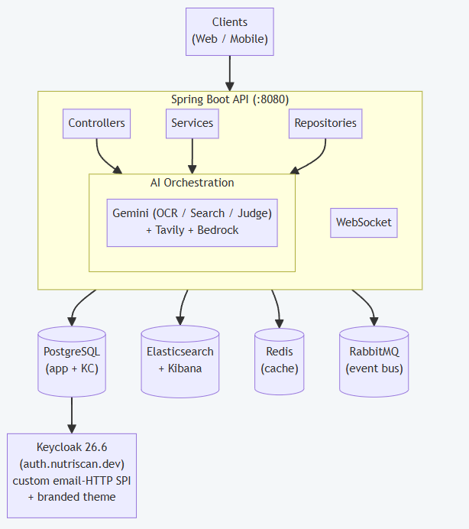
Figure 1. High-Level System Architecture
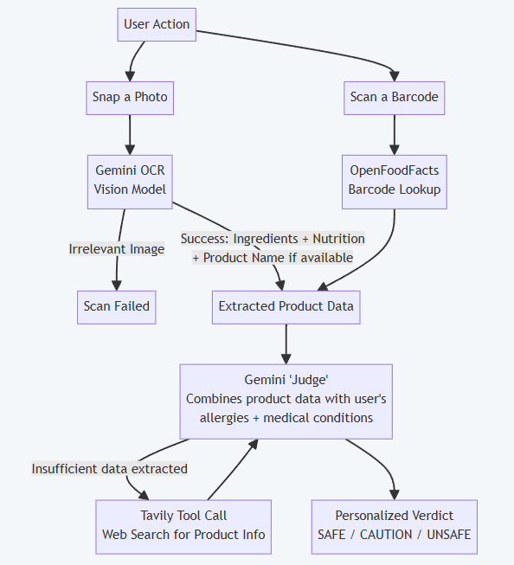
Figure 2. AI Food-Safety Pipeline
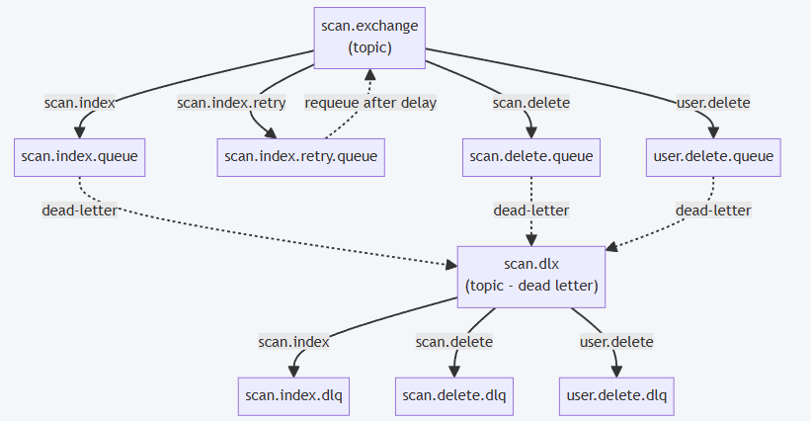
Figure 3. RabbitMQ Event Topology
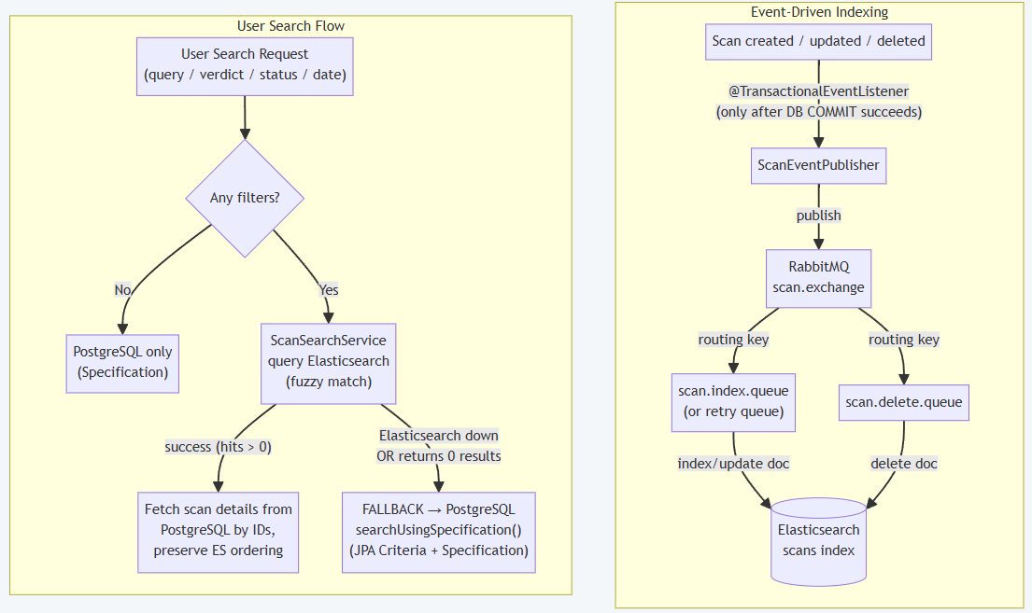
Figure 4. Search Flow: Elasticsearch, RabbitMQ, and PostgreSQL Fallback
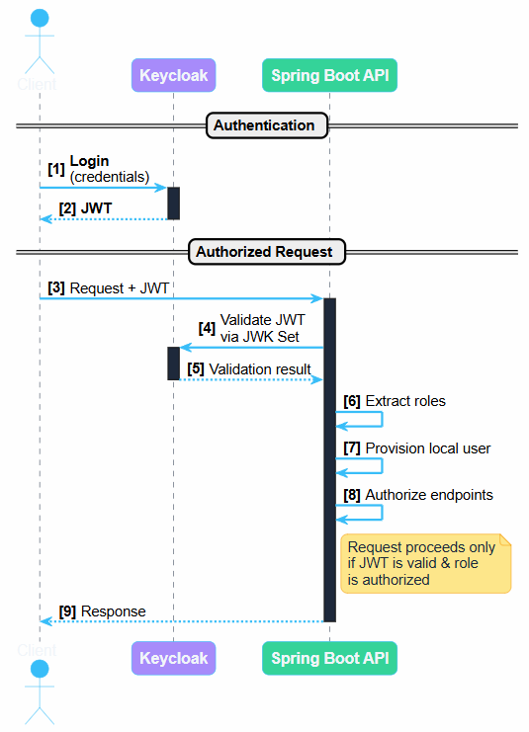
Figure 5. Authentication & Authorization Flow
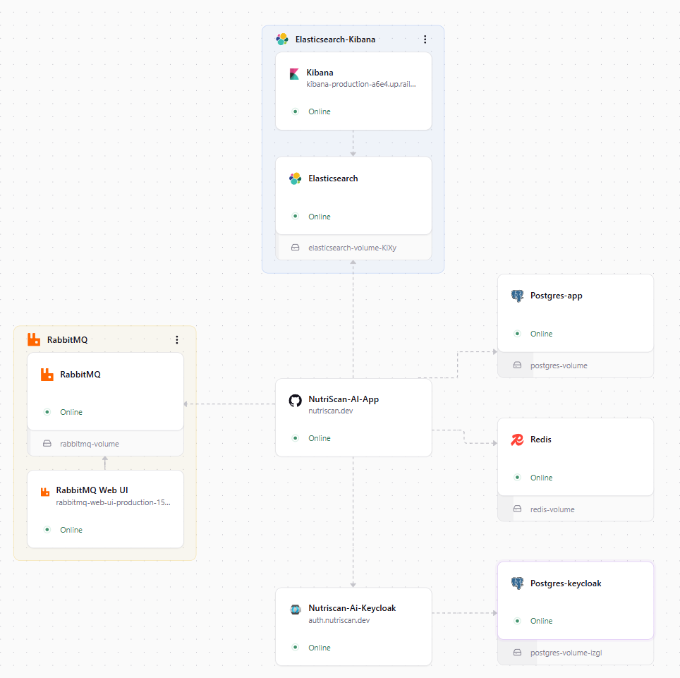
Figure 6. Railway Deployment Architecture

ERD — Entity Relationship Diagram

Database Schema
The application schema is managed and versioned by Flyway migrations. The domain model is
organized around a central User entity with related entities for safety, nutrition, and family coverage:
- User & profile (users, profile data, user_allergy)
- Family members (family_member with independent family_member_allergy) verdict can be computed for each household member
- Scans (scan records with ingredients, verdict, flagged ingredients, and status)
- Daily tracking (daily_tracking and daily_tracking_meal) for per-day meal & nutrition aggregation.
- Search sync (elasticsearch_sync) for the ES to DB reconciliation and indexing bookkeeping.
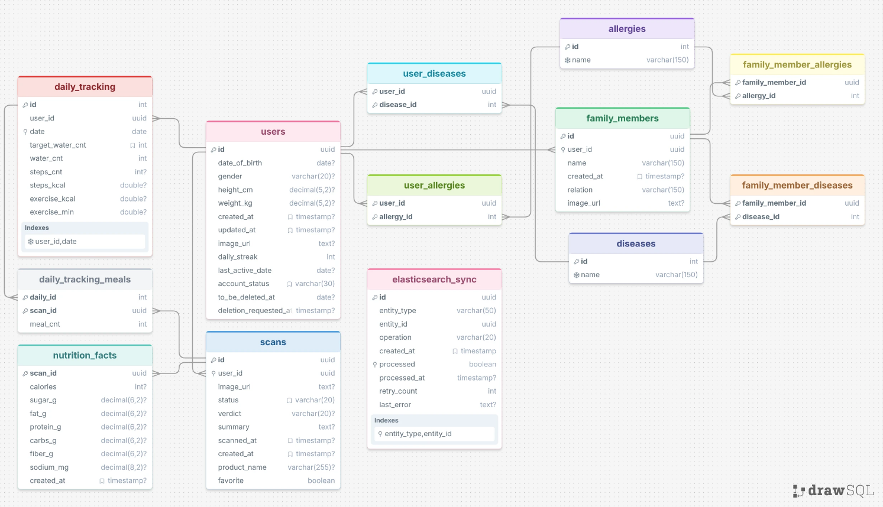
Figure 7. Backend database schema
The entity-relationship diagram of the local Android Room schema (version 17). users is the central entity; daily_tracking, food_log, saved_scans, and streak are all keyed by userId. diseases and allergies are reference catalogues referenced by ID sets on the user profile. exercises belongs to exercise_categories; workout_log records per-day completion.
The iOS client does not maintain a local relational database; it uses in-memory caching and UserDefaults for lightweight persistence, with the backend as the authoritative data store.

Use Case Diagram
The use-case diagram groups the application’s capabilities into seven packages — Account, Scanning, Tracking, Exercise, Content, Assistant, and Settings — against the Registered User and Family Member actors, with the NutriScan backend, Keycloak, and the third-party APIs as external systems. The same diagram applies to both the Android and iOS clients, since the feature set is identical.

Class Diagram
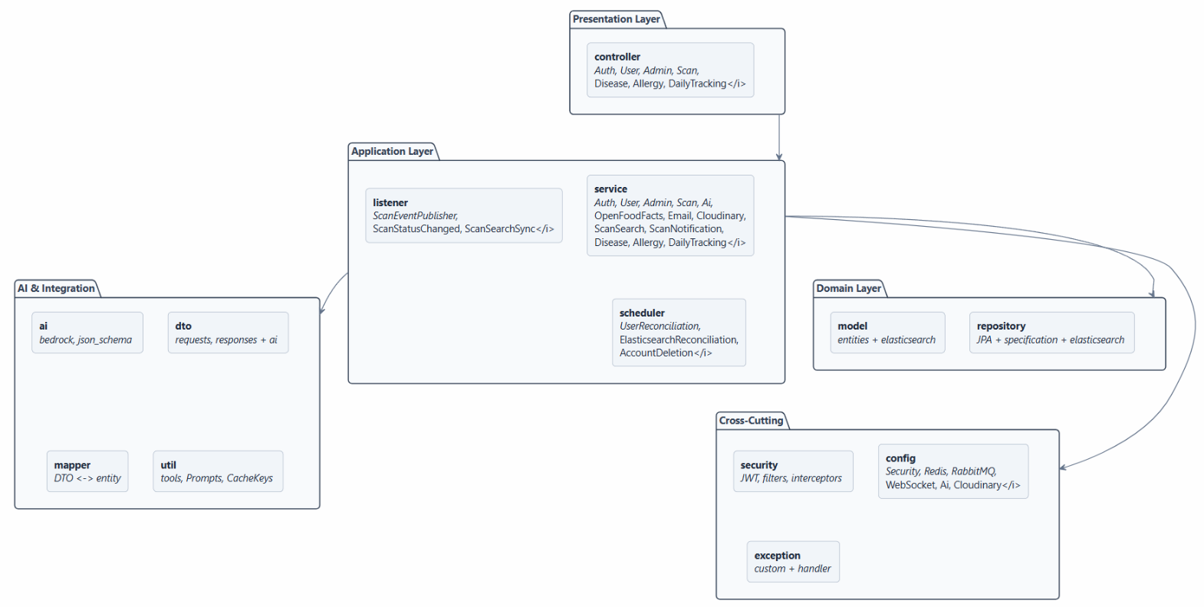
Figure 8. High level class diagram for backend structure
The Android class diagram shows the layered structure: domain models and repository interfaces at the centre, use cases depending only on those interfaces, data-layer implementations satisfying them, and a representative MVI triad (State / Event / Effect + ViewModel) on the presentation side.
The iOS class diagram mirrors this structure, replacing the MVI triad with an @Observable ViewModel and SwiftUI View, and replacing Hilt/Room with DIContainer / URLSession.

PART 3.2: Screenshots

iOS Application
The iOS application follows the shared product flows using native SwiftUI screens and iOS-specific navigation, HealthKit, camera, speech, and notification integrations.

Android Application
The Android application follows the same product flows using Jetpack Compose, CameraX, Room-backed state, type-safe navigation, and Android platform services.

Cross-platform Screenshot Register
# | Screen | Caption
1 | Splash | Branded launch screen.
2 | Onboarding | Three-page introduction to the application.
3 | Login | Email/password sign-in with Google OIDC option.
4 | Register | Account creation with validation.
5 | Profile setup | Gender, date of birth, height, and weight collection.
6 | Allergies / conditions | Health profile — the input to every verdict.
7 | Home | Daily summary: calories, water, steps, streak, top news.
8 | Scan — camera | Unified barcode and photo capture.
9 | Product details — Safe | A product cleared against the user’s profile.
10 | Product details — Unsafe | Flagged ingredients with reasons.
11 | Nutrition facts | Full macro and micro breakdown.
12 | Scan history | Search, verdict filters, and date filtering.
13 | Saved scans | Favourited products.
14 | Calories | Daily target, macros, and the food log.
15 | Calories history | Per-day breakdown over time.
16 | Steps / step history | Automatic step counting and history.
17 | Exercises | Catalogue by category with search.
18 | Workout | Demonstration, instructions, calorie estimate.
19 | News | Nutrition and health article feed.
20 | NutriGPT chat | Cited answers rendered as Markdown.
21 | NutriGPT voice | Hands-free assistant mode.
22 | Profile | Metrics, BMI, TDEE, allergies, conditions.
23 | Family members | Per-member allergy and condition profiles.
24 | Notification settings | Per-type toggles and quiet hours.
25 | App settings | Theme and language.
26 | Arabic / RTL | The same screens fully mirrored.
27 | Dark theme | Dark palette across key screens.

Backend / Admin System
No separate backend admin-interface screenshots were supplied. Backend behavior and infrastructure are represented by the architecture, deployment, ERD, and class diagrams in Part 3.1.

References

Project resources
Android source repository — https://github.com/yusefellban/NutriScan
iOS source repository — https://github.com/OTech-Company/NutriScan
Backend source repository — https://github.com/ReemMohy259/NutriScan-AI
Android Project board (Trello) — https://trello.com/b/3j0IimeG/nutriscan
iOS Project board (Trello) — https://trello.com/b/4tkFsGUD
UI/UX design (Figma) — https://www.figma.com/design/zs5EkmcWPyQJvwWY5awVQc/NutriScan

Platform and framework documentation

Android
Android Developers — https://developer.android.com
Jetpack Compose — https://developer.android.com/jetpack/compose
Guide to app architecture — https://developer.android.com/topic/architecture
Room persistence library — https://developer.android.com/training/data-storage/room
WorkManager — https://developer.android.com/topic/libraries/architecture/workmanager
CameraX — https://developer.android.com/training/camerax
Kotlin Coroutines — https://kotlinlang.org/docs/coroutines-overview.html
Material Design 3 — https://m3.material.io

iOS
Apple Developer Documentation — https://developer.apple.com/documentation
SwiftUI — https://developer.apple.com/documentation/swiftui
Swift Concurrency — https://docs.swift.org/swift-book/LanguageGuide/Concurrency.html
Observation framework — https://developer.apple.com/documentation/observation
HealthKit — https://developer.apple.com/documentation/healthkit
AVFoundation — https://developer.apple.com/documentation/avfoundation
Speech framework — https://developer.apple.com/documentation/speech
UserNotifications — https://developer.apple.com/documentation/usernotifications
Swift Package Manager — https://www.swift.org/package-manager

Libraries and services

Android
Google ML Kit Barcode Scanning — https://developers.google.com/ml-kit/vision/barcode-scanning
Dagger Hilt — https://dagger.dev/hilt
Retrofit — https://square.github.io/retrofit
OkHttp — https://square.github.io/okhttp
Coil — https://coil-kt.github.io/coil
AppAuth for Android — https://github.com/openid/AppAuth-Android

iOS
Kingfisher — https://github.com/onevcat/Kingfisher
AppAuth for iOS — https://github.com/openid/AppAuth-iOS
SwiftUI-Shimmer — https://github.com/markiv/SwiftUI-Shimmer

Shared
Keycloak — https://www.keycloak.org/documentation
OpenFoodFacts API — https://world.openfoodfacts.org/data
NewsAPI — https://newsapi.org/docs
Firebase — https://firebase.google.com/docs

Concepts
Robert C. Martin, Clean Architecture: A Craftsman’s Guide to Software Structure and Design, Prentice Hall, 2017.
Model-View-Intent on Android — https://developer.android.com/topic/architecture/ui-layer
SwiftUI data flow and state — https://developer.apple.com/documentation/swiftui/managing-model-data-in-your-app
Offline-first application design — https://developer.android.com/topic/architecture/data-layer/offline-first
Mifflin-St Jeor equation (BMI / TDEE derivation) — American Journal of Clinical Nutrition, 51(2), 1990.

Backend
1. Spring Boot Reference Documentation — https://docs.spring.io/spring-boot/
2. Spring AI Reference Documentation — https://docs.spring.io/spring-ai/reference/
3. Keycloak Documentation — https://www.keycloak.org/documentation
4. RabbitMQ Documentation — https://www.rabbitmq.com/docs
5. Elasticsearch Reference — https://www.elastic.co/guide/en/elasticsearch/reference/current/index.html
6. Redis Documentation — https://redis.io/docs/latest/
7. OpenFoodFacts API — https://world.openfoodfacts.org/data
8. Tavily Search API — https://docs.tavily.com/
12. Resend Email API — https://resend.com/docs
13. Railway Documentation — https://docs.railway.app/
14. NutriScan Project Repository (Backend) — https://github.com/ReemMohy259/NutriScan-AI.git

